Teige Hansen
Professor Taplin
IT Essentials
March 28, 2024

How to Install Windows 11 on a Virtual Machine

Table of Contents
Part 1: The Windows Download………………………………………………………………. 3
Part 2: Creating a New Virtual Machine………………….…………………………………… 4
Part 3: Configuring Our Virtual Machine……………………………………………………... 5
Part 4: Setting up the Windows Install……………….………………………………...……... 6
Part 5: Final Setup.…………………………………………………………………………….. 7
Sources.………………………………………………………………………………………... 8

Part 1: The Windows Download
The first step is to open the Microsoft Edge browser and search for “microsoft windows 11 download,” or by using the provided link: Download Windows 11 (microsoft.com). From there, scroll down to “Download Windows 11 Disk Image (ISO) for x64 devices.” In the drop down, select, “Windows 11 (multi-edition ISO for x64 devices),” select “Download Now.”
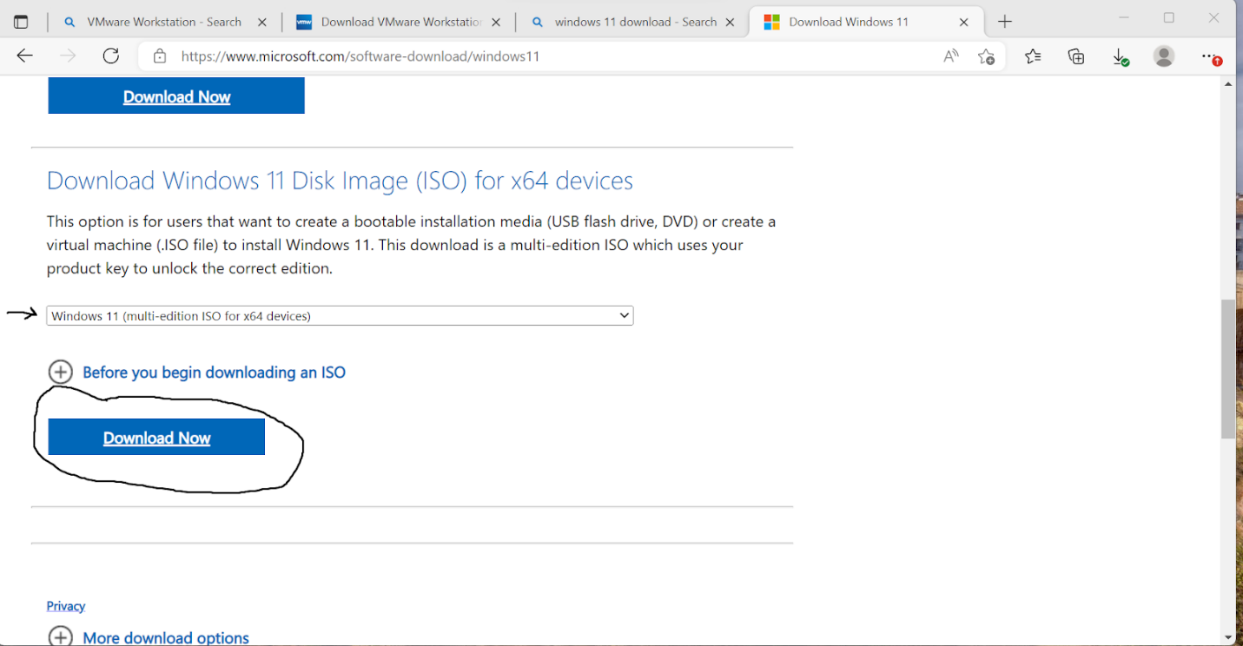
When prompted, fill in the Language option with “English (United States),” and click confirm. Click “64-bit Download.”

Part 2: Creating a New Virtual Machine
Open up the “VMware Workstation Pro” application. Under the “Library” Column, right click the open space and select “New Virtual Machine…”
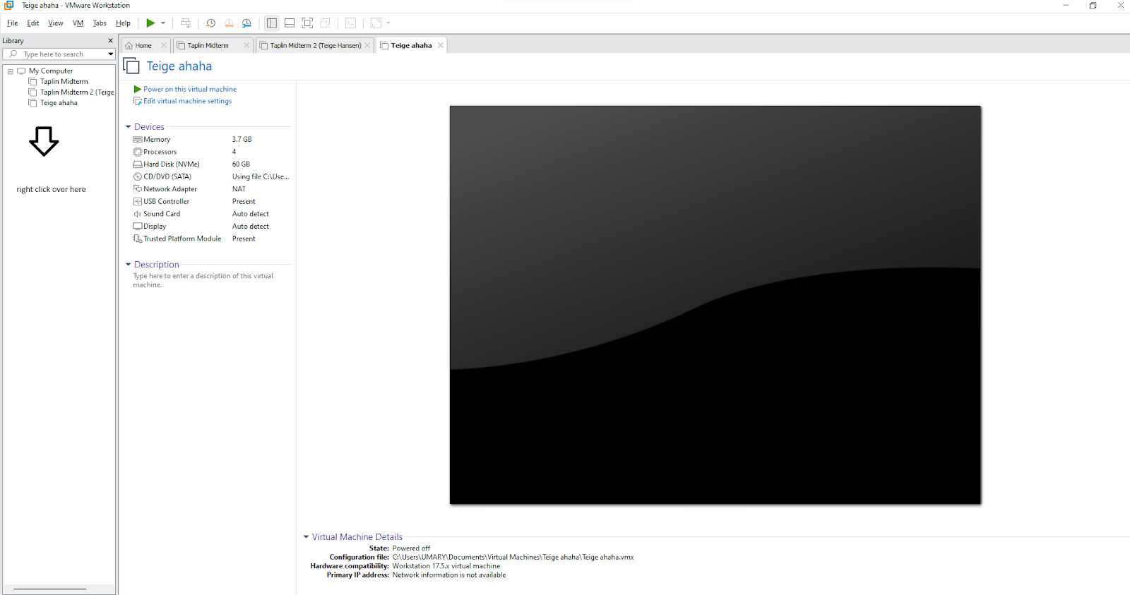
In the new tab, choose “Typical,” hit next. Now choose the “I will install the operating system later” option, hit next. In the multiple choice style prompt, select “Microsoft Windows” before putin in the dropdown “Windows 10x 64,” hit next. Name your virtual machine and hit next. Set disk size to 60 and hit next. Select “Split virtual disk into multiple files. Hit next and then “Finish.”

Part 3: Configuring Our Virtual Machine
For this part, click on “Edit virtual Machine settings.” In this window, select the options tab at the top and find “Access Control.” Press “encrypt” and set a password. Go back to the “Hardware” tab and select “add” at the bottom of the window. Hit “Trusted platform module” and finish. Find the CD/DVD (SATA) option. Select “Use ISO image file” and browse for the previously downloaded windows file we obtained in Part One of this guide. In the “Memory” option, have about 3800 MB of memory selected, or 3.8 GB. For “Processors”, have 4. Click “Ok” at the bottom to conclude this section.
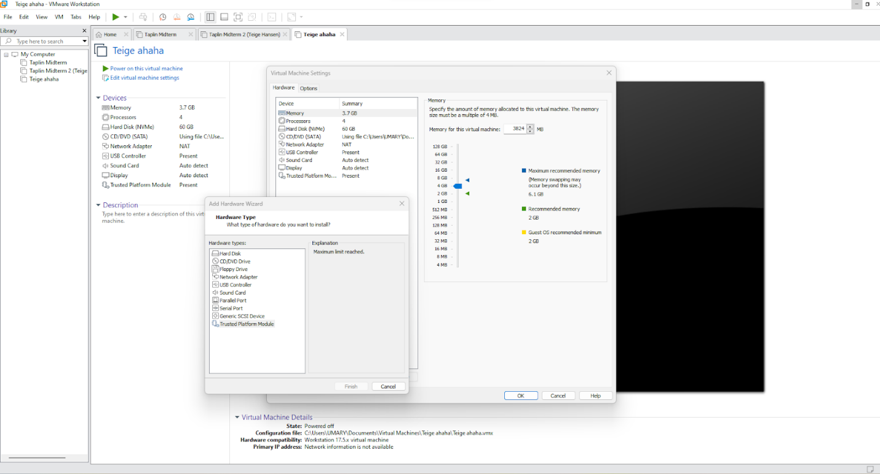

Part 4: Setting up the Windows Install
From now on, the process is relatively straight forward, but here is how to set up and get to the Windows install. Power on your virtual machine. When prompted, hit a button on your keyboard (any one should do but I prefer spacebar). If you are not quick enough, you may have to wait for a moment while the machine loads up a blue screen. If that happens, select the top option by pressing the “enter” key on your keyboard. When prompted for your language, select “english,” before hitting next. When asked for your Microsoft account, you can either choose to type it in or you can click “Sign in options” and then select “I don't have a product key.”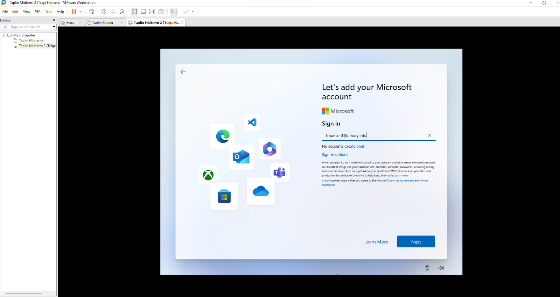 In the dropdown, select “Windows 11 Pro,” before hitting next. Agree to the terms of service and the hit next. Select “Custom install Windows Only (advanced).” proceed past the next tab. Click on Install and wait for your windows Operating system to download.

Part 5: Final Setup
For the final stretch, we can start by selecting “United States” and next. Click on US and next. Select skip. Name your device and hit next. Choose “for personal use.” Hit “Sign in options” and “offline account.” You can skip for now. Type in the name of this account. Choose a password and confirm. Set three security questions. Finally, turn off all options in the privacy tab. If you followed the instructions in this guide carefully, you should be seeing the image below.
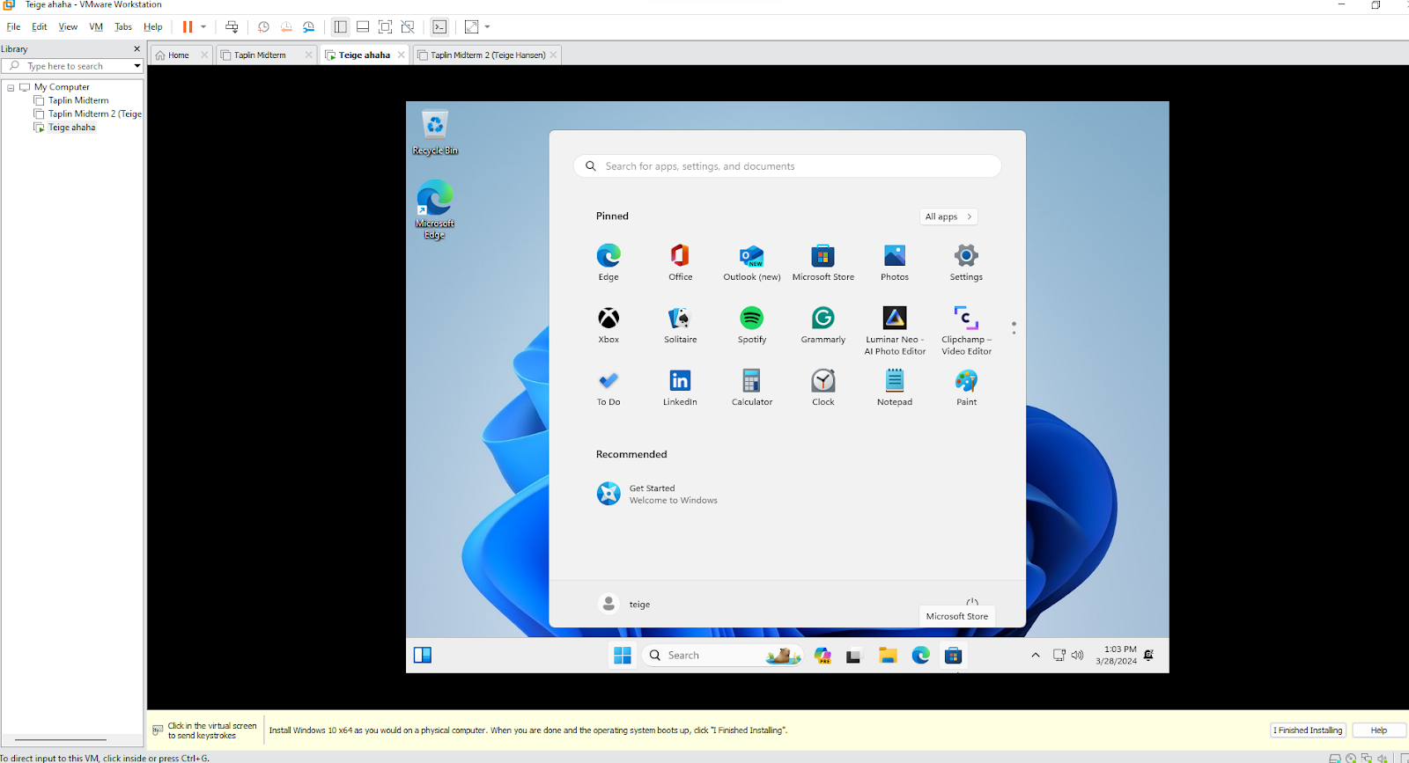

Congratulations! You have successfully installed Windows 11 on a virtual machine!

Sources
Hammond, John. “How to Install Windows 11: Vmware Workstation.” YouTube, YouTube, 24 Jan. 2022, www.youtube.com/watch?v=EMuw_IN-UOU.

